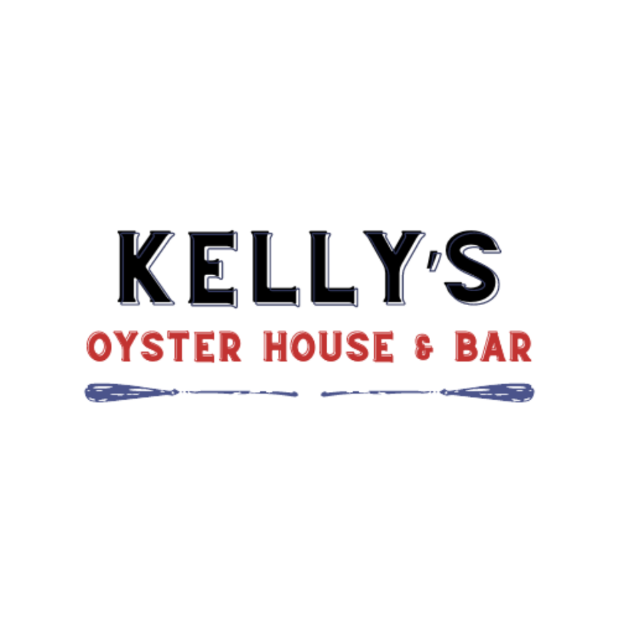
RESTAURANT WEEK DINNER THREE COURSES $40.00
APPETIZERS (choose one)
New England Clam Chowder Charleston She Crab Soup
Spanish Style Sauteed Shrimp with Lemon, Olive Oil, Chili Seasonings, Garlic Bread
Broiled Oysters- Four Broiled Oyster with Garlic Butter and Parmesan
Sweet Corn Hush Puppies with Cinnamon Maple Butter
Winter Salad Butternut Squash, Mandarin Oranges, Grape Tomatoes, Persian Cucumbers, Chopped Pecans, Balsamic Vinaigrette
ENTRÉES (choose one)
Chesapeake Crab Cakes Old Bay Remoulade, Grilled Asparagus, Marinated Tomatoes-Cucumbers, Au Gratin Potato Cake
NY Strip Steak Roasted Fingerling Potatoes, Broccoli, Red Wine Sauce $10 surcharge
Penne Pasta with Sauteed Shrimp, Andouille Sausage Cajun Cream Sauce, Parmesan Cheese
Seafood Linguine Pasta Shrimp, Mussels, Calamari, Chopped Tomatoes, White Wine Garlic Butter Sauce
Chicken Limone Sauteed Chicken Breast with a White Wine Lemon Butter Sauce, Au Gratin Potatoes, Grilled Asparagus
Rainbow Trout Filet Mediterranean Orzo, Tomato Cream Sauce, Grilled Asparagus
DESSERT (choose one)
Homemade Key Lime Pie Raspberry Lemon Lime Tart
Chocolate Delight Cake^{GF}
Lemoncello Cake Lemon Cake with White Chocolate Mascarpone Frosting. Strawberry Sauce, Whipped Cream and Fresh Berries
Homemade Ice Creams Black Raspberry Chocolate Chip, Dream Sycle, Mint Chocolate Chip

