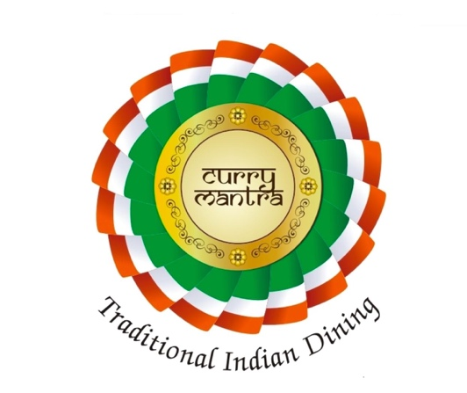
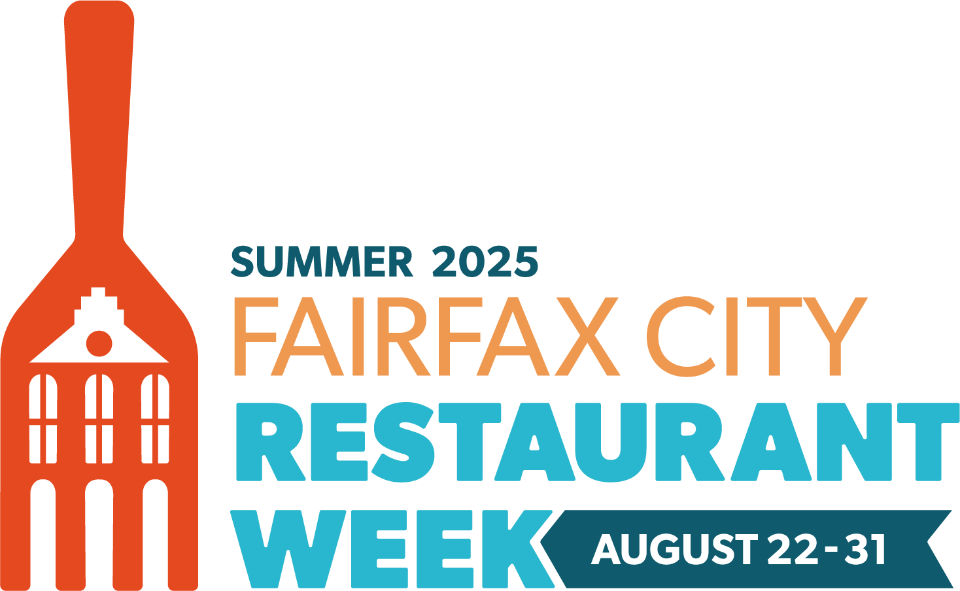
$25 Lunch Special

Includes any two-lunch special menu
All entrée served with basmati rice and naan bread.

3 Courses Meal $30/ Person

*************************
Starters (Pick One)
Samosa
Paneer Sticks
Mixed Vegetable Pakora

***********************************
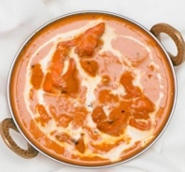
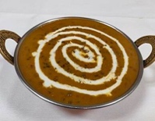
Choice of your Entrée: (Pick One)
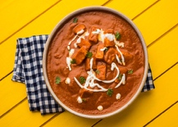
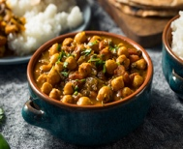
Dal Makhani Butter Chicken
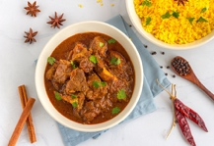
Chana Masala Chicken Tikka Masala
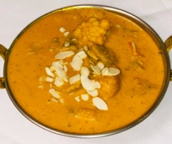
Mixed Vegetable Korma Traditional Curry
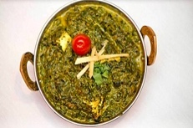
Aloo Matar Korma Curry
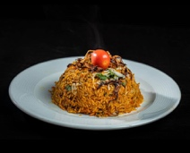
Plain Palak Vindaloo Curry
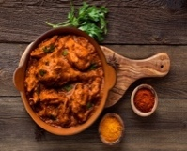
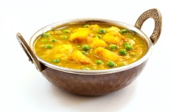
Palak Paneer Tradition Biryani (Raita)
Paneer Makhani
Paneer Tikka Masala

***************************************
Desserts (Pick One)
Gulab Jamun
Gajar Halwa
Kheer

